Solve the below problems using OOPs concept using Java.

**1. Create a class called "Person" with attributes "name" and "age". Also create a constructor and getter methods for the attributes.**

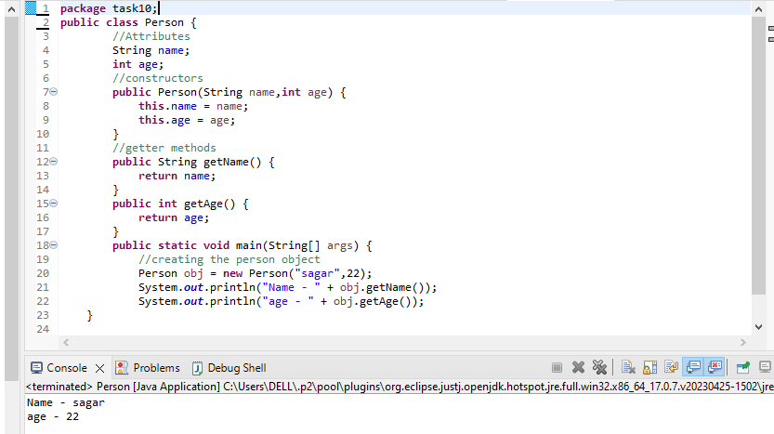

**2. From the below image, Create an implementation for a java class named Employee that represents an employee with attributes including ID, name, and salary. The class includes a method called raiseSalary(percent), which updates the salary by a specified percentage**

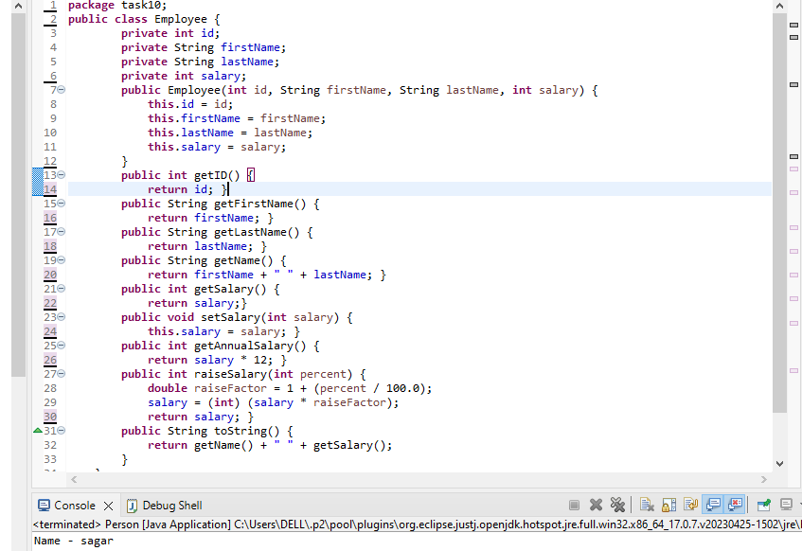

**3.Create a class circle class with radius as data member. Create two constructors (no argument, and two arguments) and a method to calculate Circumference.**

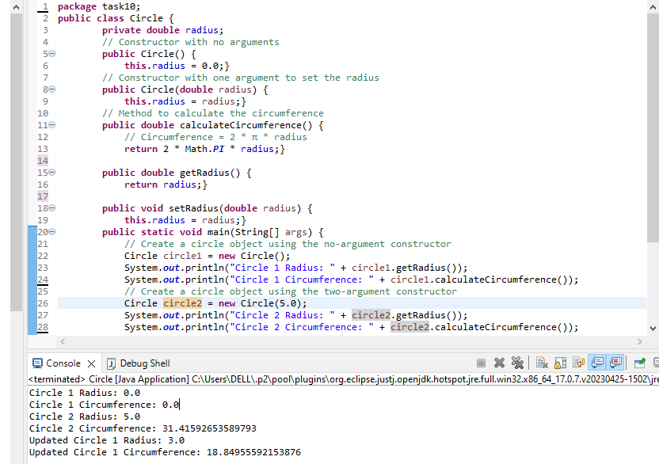

**4. Create a class Account class with balance as data member. Create two constructors (no argument, and two arguments) and methods to withdraw and deposit balance.**

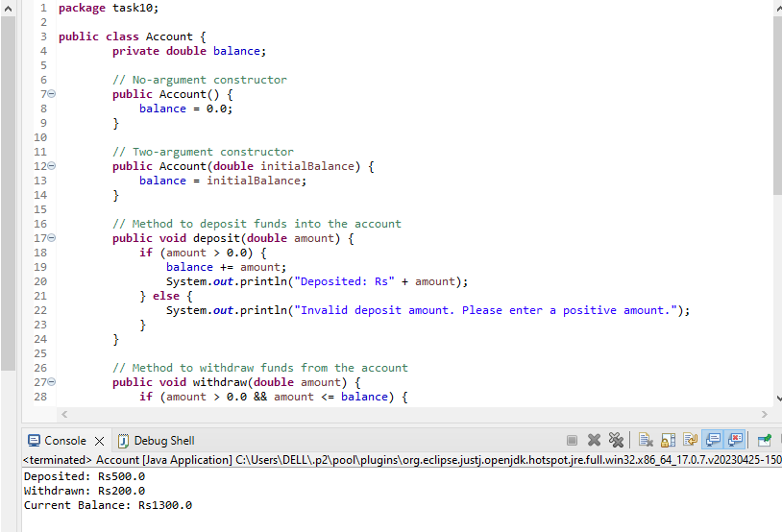

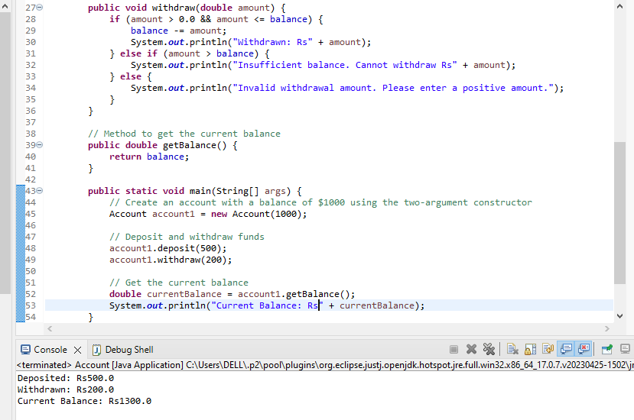

**5. Create a Tea class in Java that includes the following methods:**

**a)prepare Tea()- a method that prepares a basic tea with hot water and tea leaves.**

**b)addMilk) - a method that adds milk to the basic tea.**

**c)addSugar)- a method that adds sugar to the basic tea.**

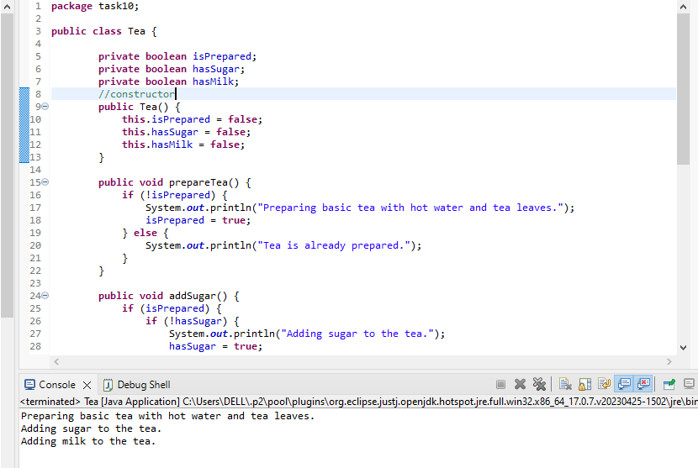

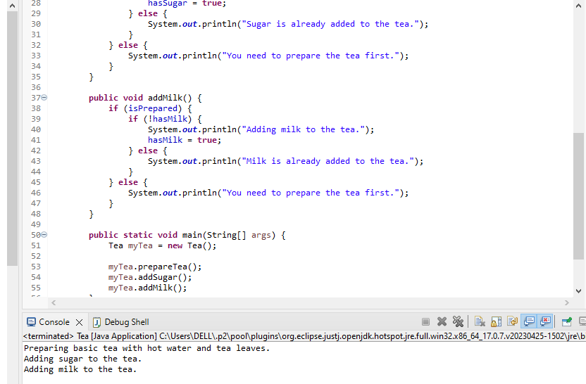

**6. Create three subclasses of the Tea class: Black Tea, GreenTea, and HerbalTea. Each subclass should override the prepare Tea() method to prepare the specific type of tea (black tea, green tea, or herbal tea) with appropriate ingredients and brewing times.**

Class Tea

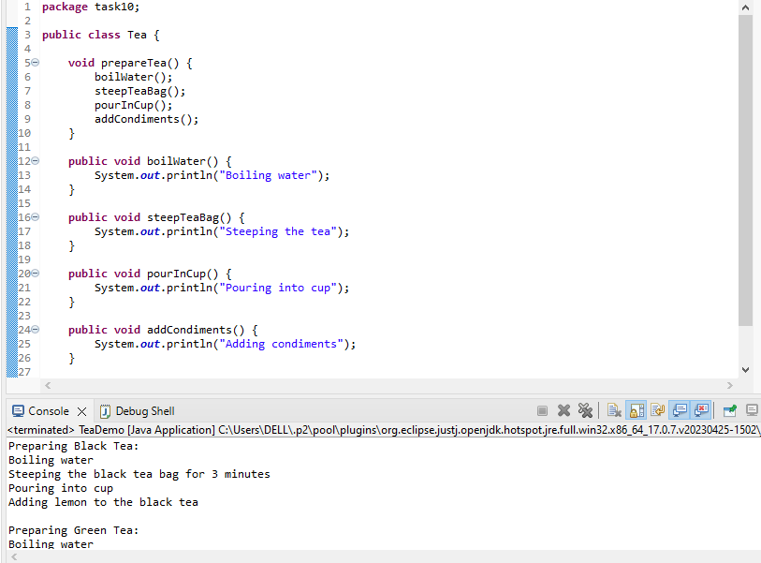

Class Black Tea

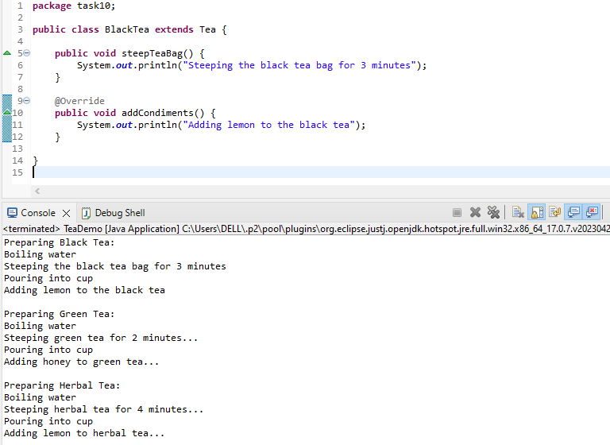

Class Herbal Tea

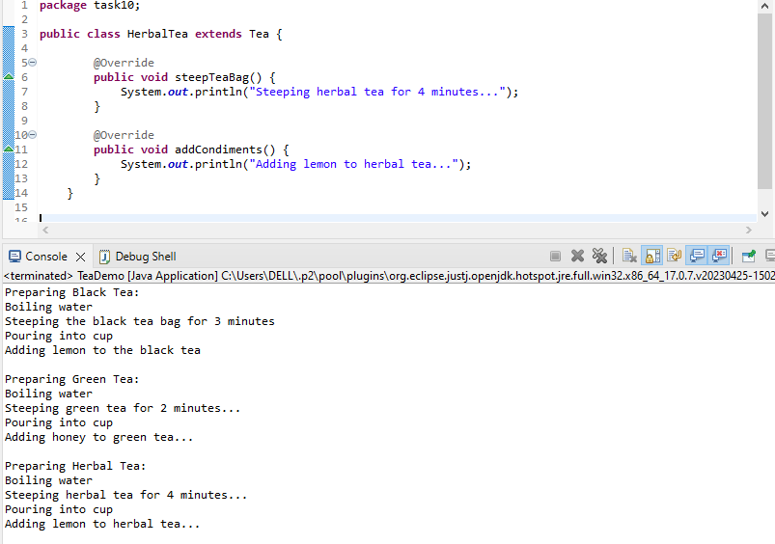

Class TeaDemo

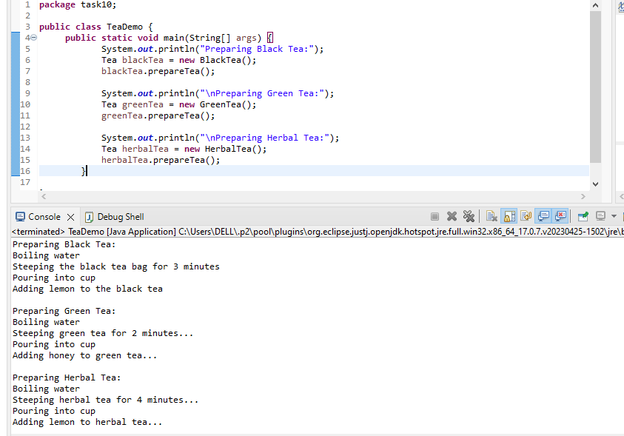

**7. Implement polymorphism in your program by creating an array of Tea objects that includes instances of the Tea class and its subclasses.**

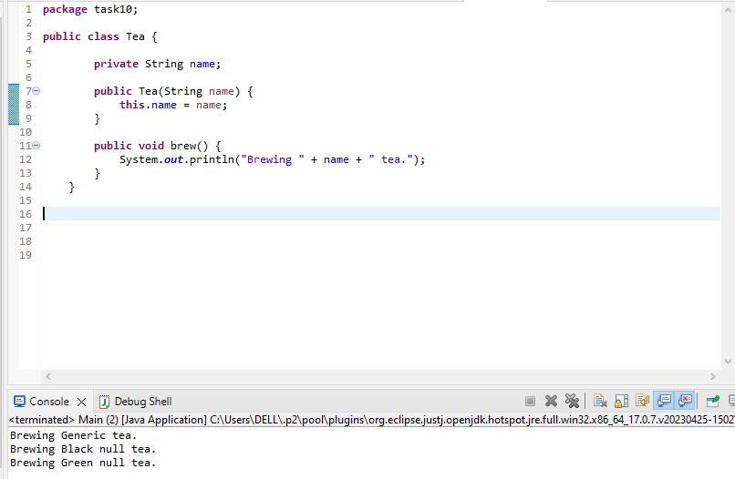

BlackTea class

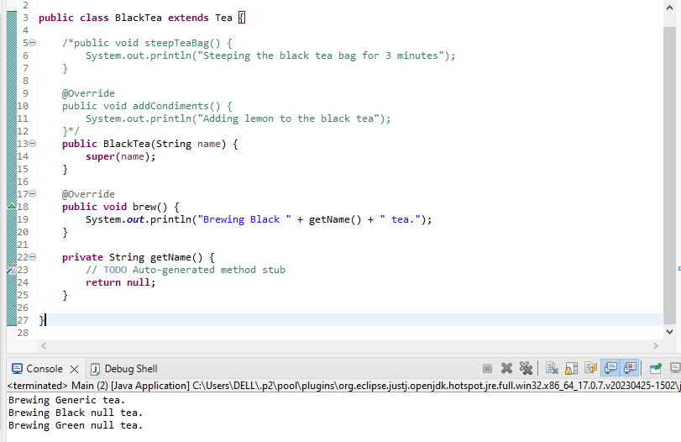

GreenTea class

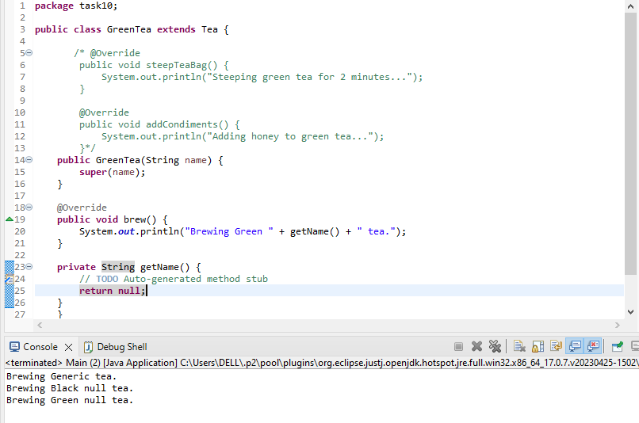

Main class

